Nike Inc Sustainability

1. **Introduction clearly setting out the report contents.**

The Company Chosen is Nike Inc. which is a multinational American company that specializes in Apparel and accessories as well as providing sports equipment. The main focus in this report is to asses wether Nike Inc is environmentally sustainable. According to RobescoSAM index used by Dow Jones, Nike Inc. has a index of 71 whilst adidas on the other hand has an index of 100 which means adidas is leading the industry. Nike has been seen being sustainable both socially and environmentally, with targets set to zero emissions for 2025, as well as partnering up with NGO’s to tackle the problem of the melting arctic as well as managing the supply chain to be ethical and no tolerance for sweat shops.

1. **Methodology for searches of the academic literature and other sources**

The latest sustainability report that Nike Inc released, the report that demonstrates Nike’s most critical sustainability aspects and topics they will look at, as well as setting targets and objectives annually. The source above will aid this report to compare Nike’s set targets against its actual performance, this would give us insight on whether there is progress in the company’s sustainability. Furthermore, other research will further be assessed and will determine whether Nike Inc is a becoming a more sustainable Company with regards to the environmental aspect of sustainability.

1. Company overview (100 words)

Nike Inc is a company that specialises in Sports apparel, which competes directly with the other big boys in the market adidas. The organization reported "Move to Zero" on Thursday, an extensive supportability plan intended to "help protect the future of sport." The program expands after existing plans placed by Nike, including Nike's expect to control offices with 100% sustainable power source by 2025 and work with net-zero carbon discharges.

1. **Sustainability Performance Data for the chosen area of evaluation**

The Data set below displays four different variables that Nike Inc. has targeted to improve towards its environmental responsibility and its business sustainability. Nike Inc has highlighted climate change as a priority issue according to both its 17/18,16/17 sustainability reports. The first variable that helps to address the issue of climate change is average product carbon footprint the company targets 10% reduction each year however the results were unfavourable, due to the slight increase. Nike justifies this is due to an increase in both material per unit (apparel getting heavier) and overall manufacturing emissions intensity (driven by grid electricity in Vietnam and style/model mix).

|  |  |  |  |  |
| --- | --- | --- | --- | --- |
|  | **Average Product Carbon Footprint (kg CO2e/unit)** | **Performance Renewable Energy – Owned or Operated (%)** | **Freshwater Use Per Kg – Textile Dyeing and Finishing (L/kg)** | **Energy Consumption Per Unit – Key Operations (kWhe/unit)** |
| **Year 16/17** | 7.19 | 20 | 126.5 | 4.29 |
| **Year 17/18** | 7.45 | 19 | 109.3 | 4.39 |
| **Targets** | Deliver products for maximum performance with minimum impact, with a 10% reduction in the average environmental footprint | Reach 100% renewable energy in owned or operated facilities through FY25 and encourage broader adoption, as part of our effort to control absolute emissions | Innovate and adopt new approaches to reduce water use in our supply chain, with a 20% reduction in freshwater use in textile dyeing and finishing per unit of production | Decrease energy use and CO2e emissions 25% per unit in key operations (inbound and outbound logistics, distribution centres, headquarter locations, finished goods manufacturing, and NIKE-owned retail) |

1. **Critical evaluation**

As previously mentioned Nike Inc has set goals to zero emissions. . The report demonstrates Nike’s most critical sustainability aspects and topics they will look at, as well as setting targets and objectives annually. The report also displays data sets over the years to monitor progress of the set targets. Unfavourable results have been recorded for the year 17/18. A slight decrease (1%) in the amount of Renewable energy. Nike Inc has explained this increase due to the building of new plants that are not yet 100% operational. Nike expects to see a decrease in the years ahead. Producing the developing clean energy is the seventh sustainable development goals. And if Nike Inc is to be seen as being environmentally sustainable they must be able to increase their clean energy use and reduce the use of non-Renewable energy, which is proven to be unhealthy for the environment and the climate In general.

Nikes point was made clear with their intention to become more sustainable. They have not only helped in themselves by setting targets for emissions and energy use, but they intend to change and help other designers in the market to become more sustainable through the sharing of knowledge. Nike as of late banded together with Saint Martins to make a manual for Designers that spreads out the standards of circular structure, alongside contextual analyses from organizations that have done earth shattering work on these fronts. (Fast Company, 2019)

The $3 trillion worldwide attire industry remains the second biggest modern polluter, following oil and gas . The business is complicated , including long and different supply chains. Each progression of the chain requires consumption and puts pressure on our carbon emissions. Working 566 production lines, utilizing over a million laborers, Nike is liable for the prosperity of those laborers and the networks they live in. By limiting the environmental emission, improving development, and changing assembling, Nike has repositioned its production network to utilize sustainability as a vital development motor. To limit squander in 2015, Nike utilized 54 million pounds of processing plant scrap and changed it into premium material. Also, the organization diminished water use per unit in footwear by 43% . These activities presented Nike's closed loop system another strategy for planning, completing, and preparing materials. (Digital.hbs.edu, 2019)

Despite the fact that Nike has made a couple of positive changes to its natural practices and is a member of the Sustainable Apparel Coalition, regardless, it has long way to go before it can really be known as a sustainable brand. Nike uses a couple eco-friendly materials including natural and reused cotton and polyester, limits off-cuts in parts of its assembling procedure and has a waste and water decrease system set up in a large portion of its production network. It has likewise made an open pledge to decrease its carbon outflows by over half by 2025.

Although Nike has not focused on hazardous dangerous materials from its inventory network, which is a major issue for laborers who are presented to them and even the individuals who wear the items, and the environment in general. Nike's utilization of dangerous synthetic compounds has additionally been condemned by Greenpeace, who have voiced concern in regards to the contamination of conduits. (Good On You, 2019)

1. **Recommendations for improvement**

All in all Nike Inc is not considered to be the most sustainable company although, we have seen the efforts from Nike in different ways in becoming and leading in sustainability. Nike Inc would skyrocket in revenue if the company leads the industry in sustainability and showing other market competitors how it is done. One issue Nike Inc must focus on and have been heavily criticised on is the hazardous materials used, a solution must be looked upon when looking at the materials being used, in order to become more environmentally sustainable.

1. **Conclusions**

In conclusion, Nike is trying to set the best example for sustainability as well as developing new ways to reduce emissions, water use in an effort to become more sustainable and drive the company to longer and a more prosperous future. Although , Nike may be not lead the charts for sustainability but they have proved they are working thoroughly in order to become.

**Analysis of Social Media Data Set**

1. **Introduction – a brief overview of the contents of your analysis. (50 words)**

The aim of this report is to study the extent of recognition for climate change by examining and studying several related search terms on twitter. Illustrations will help study and visualise the numbers of searches and an overall conclusion given.

1. **Search Methodology –**

After extensive quantifiable research using twitter and tableau for the matter of climate change, the data gathered has its limitations, to start with, Tags was used to gather one percent of the total information or tweets that are on twitter, since the amount of tweets on twitter is a great deal and would take a lot of time to process. The downside to that is the accuracy of the information. Although Tags aids the report in pinpointing the most important search terms, this shows the extensive need to address these issues in order to become more sustainable. The data gathered is later on processed with the program named Tableau which compartmentalises and graphs to make the data gathered more graphic and visual.

1. **Presentation of Results and critical analysis (400 words).**

The data gathered is illustrated below in graphs, which show different search terms that are related to the topic of climate change. To start with, a search for #Arctic was seen to give 180 tweets an hour at peak. The arctic is interconnected with climate change, according to Greenpeace USA, 2019 the individuals and creatures that live in the Arctic rely upon its extraordinary biological system. For them environmental change isn't a discussion, it's a day by day reality. Also, with the area warming twice as quick as the remainder of the world, ice is dissolving much quicker, since the sea ingests the warmth. The importance of this issue is justified with the amount of tweets. The Arctic can play a key job in worldwide maintainability assets such as Oil, Water Energy and Gas. Oil companies must be able to extract these energy sources without harming the unique ecosystem of the arctic since many people depend on, and to ensure a long and sustainable future. This issue must be looked at since people have described it as a #ClimateEmergency! And was the second most trending hashtag when searching for #Arctic. The Obama administration banned oil companies for extracting for 2 years but was only temporary, another solution must be looked upon.

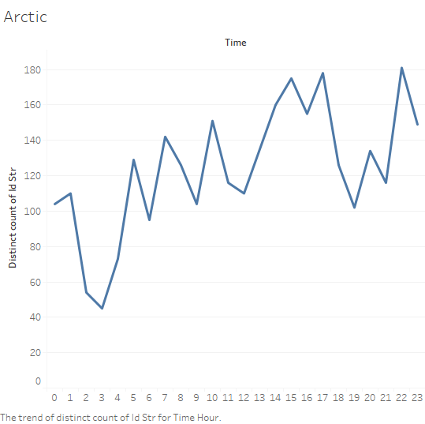Figure 1: Tweets trend by hour for search term #Arctic

To analyse and asses the level of importance to the people for climate change another search term is conducted using #climatechange, this search is more broad and is expected to give more results. As expected the search gave just over 4900 results, and at peak times giving about 950 tweets. Although as you can see below there are heavy retweets on several accounts. The graph below organises the most retweeted accounts. And a dive into twitter gives us a look at these accounts. @PaulEDawson was the highest retweeted, having almost 50k followers, Paul’s type of work is unclear still from twitter but he is an active supporter of climate change giving his followers an understanding of the changes occurring in the environment and the most recent significant issues we must look at and consider.

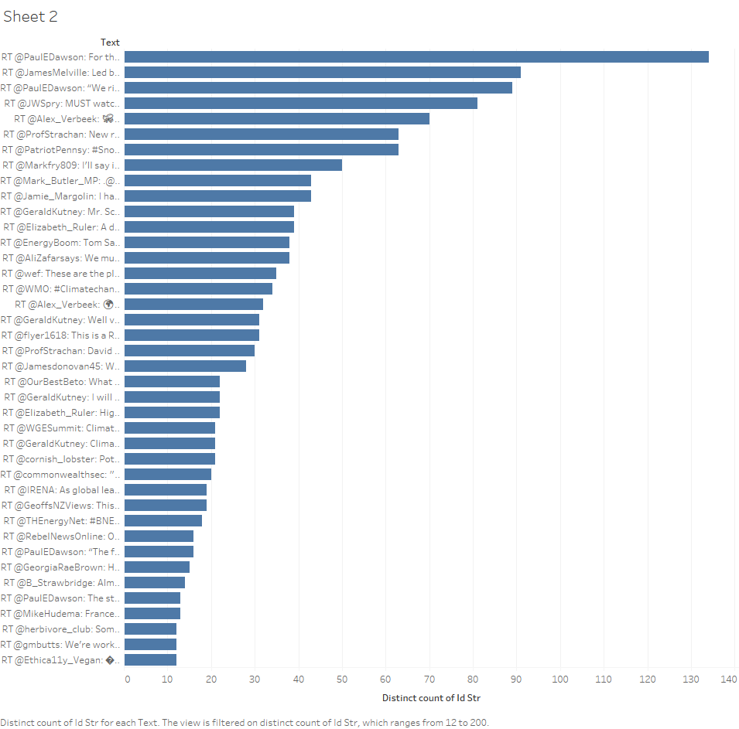

The last search conducted and graphed was #SolarEnergy. Which was interesting because companies transitioning from Non-Renewable energy to Renewable energy tweet about their transitions in hopes to affect the climate in general and to avoid people who are working towards improving society such as pressure groups and protest groups, that would adversely affect companies Image and Branding. The graph below shows the highest retweeted whom is Micheal George Henry (Mike) Hudema, a Canadian activist who has worked for advocacy organizations including Greenpeace and Global Exchange. As seen below a tweet of his blew regarding the company of Tesla whom supplied a whole island with Renewable Energy. Such acts by companies do not go unnoticed. Tesla have positively operated against climate change in a sustainable manner by addressing the issues of climate change and trying to help it. This positively affected Tesla brand image and have answered the exclamations of people from twitter regarding the need to help and affect climate change.

Figure 2 Climate Change Re-tweets accounts

Figure 3 Solar Energy Retweet Accounts

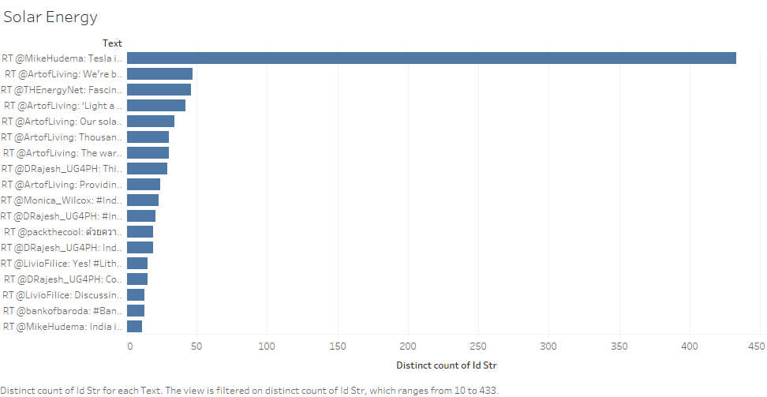

1. **Conclusions (100 words).**

In conclusion, Tags, Twitter and Tableau have aided this report in studying the extent to which climatechange is being discussed and reviewed by the public online. The results of this report showed most tweets on #Climatechange, over 4900 results, in relation to the search #Arctic which resulted in just over 1000 results. Retweets and important information was obtained when looking at the accounts, companies, people and pressure groups were all involved in the tweets which gives us a real perspective on the ongoing issue of climate change.

1. **References (single reference list at the end of document).**

Digital.hbs.edu. (2019). *NIKE: Is it the Sustainability Transformation of the Decade? – Technology and Operations Management*. [online] Available at: https://digital.hbs.edu/platform-rctom/submission/nike-is-it-the-sustainability-transformation-of-the-decade/ [Accessed 16 Dec. 2019].

(Digital.hbs.edu, 2019)

Fast Company. (2019). *Nike is launching a guide to sustainability for brands–get it here*. [online] Available at: https://www.fastcompany.com/90350603/nike-is-launching-a-guide-to-sustainability-for-brands-get-it-here [Accessed 16 Dec. 2019].

(Fast Company, 2019)

Good On You. (2019). *How Ethical is Nike?*. [online] Available at: https://goodonyou.eco/how-ethical-is-nike/ [Accessed 16 Dec. 2019].

(Good On You, 2019)

Greenpeace USA. (2019). *Arctic Issues & Threats*. [online] Available at: https://www.greenpeace.org/usa/arctic/issues/ [Accessed 13 Dec. 2019].

(Greenpeace USA, 2019)

Nike Inc. (2018). *FY-18 Impact Report*. [online] Available at: https://purpose-cms-production01.s3.amazonaws.com/wp-content/uploads/2019/05/20194957/FY18_Nike_Impact-Report_Final.pdf [Accessed 29 Oct. 2019].

(Nike Inc., 2018)

yearbook.rebecosam.com. (2019). *Companies | RobecoSAM Sustainability Yearbook 2019*. [online] Available at: https://yearbook.robecosam.com/companies/ [Accessed 29 Oct. 2019].

(yearbook.rebecosam.com, 2019)